**Information Systems Assignment**

**(6G4Z1103)**

**Group Number: B8**

**Tutor Name: Stephen Gordon**

**Ibrahim Chowdhury (20027089)**

**Abdulla Ibrahem (19027109)**

**Anwar Aldhufairy (20106726)**

**Bachar Alhussain (18036978)**

2020-2021

**Table of Content**

Section 1 - Executive Summary 3

*S*ection 2: System Analysis 4

2a - Description of Problems 4

Section 2b - System Requirements 4

Section 3: System Design 5

3a - Use Case Diagram 5

3b - Use Case Specifications 6

Section 4: Database Design 7

4a - Top Down ERD 7

4b - Bottom Up ERD 8

4c - Merge of Top Down and Bottom Up ERD’s 10

Section 5: SQL Implementation 11

5a - Drop and Create Statements 11

5b - Insert & Select Statements 12

Section 6: SQL Queries 13

Query 1 13

Query 2 13

Query 3 13

Query 4 13

Query 5 13

Query 6 13

Query 7 13

Section 7: Student Statements 14

Student A – Name and ID 14

Student B – Name and ID 14

Student C – Name and ID 14

Student D – Name and ID 14

Appendix A: Individual UCD Attempts 15

Appendix B: Individual ERD Attempts 16

Appendix C: Logbook 17

Appendix D: Full SQL Code 18

# Section 1 - Executive Summary

*Produce an executive summary, giving readers an overview of your report.*

*Give an introduction (background), explain the purpose of the report, give the key points of the report including the major problems and how you solved them (use bullet points), and summarise the document.*

*This is the first thing the readers of your report will read, but the last thing you should write. Should be in third person, no use of I, we etc.*

This report contains all of the content that has been done by the group, it includes in detail the sections with explanation on how the system works and how have the group been dealing with some of the problem that they have faced and ways they solved them.

The purpose of this report is that it will help you understand the skills that has been implemented and shows you some of the wide variety of different things used such as visual paradigm, databases and much more. It also overlooks on how the group managed to communicate with each other and what role each person took to complete this assignment.

There were some difficulties faced during this project such as some of the members not contributing to the task or helping the group, which had led to have problems for instance tasks were not complete. In this situation, the 2 members who contributed were excellent on the way they executed the whole of the assignment even though half of the group were absent. They both helped each other out with the work and maintained a strong level of communication, and both asked each other for help if needed even during late hours. This then elevated their work level which led them to complete the assignment. Another issue they had faced was the time they had started, because some of the members were not contributing it had led them to lose vital time on the assignment as the deadline was quickly approaching. However, this was solved with ease due to the strong communication built by the 2 members, they had made quick progress when finishing the assignment. Finally, the last problem they had faced was lack of knowledge during some of the tasks, because of the communication they had, it was also solved quickly as they helped each other when they were struggling on some parts and went through some of the useful videos which solved their issue.

In conclusion, this document has lots of information for each of the section, it will give you a basic understanding on how this project worked and will show you how the problems were overcome. It will also illustrate how the group adapted in some of the situations and show how they gained more confidence during this project.

# *S*ection 2: System Analysis

## 2a - Description of Problems

*List ALL the problems of the system. Bullet points can be used here. There are at least seven of these.*

1. The reservation might take several days or weeks in advance of the actual hiring.
2. The reservation gets lost with all the other reservations and rentals.
3. Another problem is that it has caused embarrassment many times because sometimes boats that had been reserved for someone could go out on hire.
4. The system failed to recognise between a rental (of a particular boat) and a reservation (for a class and size of boat), which meant that it didn’t fit with the way Mike’s did things in their business processes.
5. The list is occasionally out of date or inaccurate in some other way.
6. There’s no real system of prioritising the “service” and “repair” work, which means boats which are in heavy demand are not available.
7. The alarming frequency with which the necessary spare part is not in stock.

## Section 2b - System Requirements

*List the functional requirements and the non-functional requirements for the user and system.*

**Functional Requirements:**

* The customer requests to hire a boat.
* The hiring department gives the customer important information about boat hiring.
* The hiring department gives the customer rental information.
* The reservation details gets recorded and saved.
* Now the customer can make the payment.
* A receipt is given to the customer.
* The reservation is now confirmed and completed.
* The customer must be able to report fault through the system.

**Non-functional Requirements:**

* Boats must be available to hire.
* The hiring department should have all the necessary information about boat hiring.
* The reservation details should be kept safe and recorded.
* The system must show the return date and the boat ID that is loaned out.
* The system must ensure that the transaction of the payment is completed and secure.
* The system will give a form of receipt to show proof of transaction.
* If everything is completed correctly, the system will let the user know that everything has been complete.

# Section 3: System Design

## 3a - Use Case Diagram

*Show your finalised Use Case diagram (UCD) using the ‘MOSCOW’ system of prioritisation and representing the requirements of Mike’s Motorboats current system with written commentary explaining any decisions made in moving from the individual diagrams to the group one. The commentary should list any assumptions you have made.*

*Make sure diagram is readable and colours do not clash with the text*

*An individual use case diagram (UCD) should be drawn by each member of the group. These need to be placed into the appendix of your report to provide evidence of participation, without these you will lose marks. Each one should have a student name/number associated with it. They must all be different.*

The main purpose and function of a use case diagram is to express the dynamic view of a system. They show a simplified graphical representation of what the system should do in a use case, it also shows the different ways that a user may interact with a system. It shows the website from a user’s point of view and outlines the systems behaviour when it responds to a request. I assumed that UCDs are easy to do however it took time and effort as it is important that the UCD makes sense when it is all complete. Down below is our group UCD (use case diagram) which we made, we were given a task to create an individual UCD and then combine it to create this one big group UCD. When creating the individual UCD, it was rather simple and was easy to do, however creating the group UCD was more complex due the fact that we had many things to add and change. The individual UCD contained a simple diagram of how the system would work with less classes and actors. However, the group UCD was much more complex it had more classes, more actors and overall we had more ideas on how a use case diagram should look like. As a group we contributed ideas to get our final result which is shown down below.

(Diagram shown below)

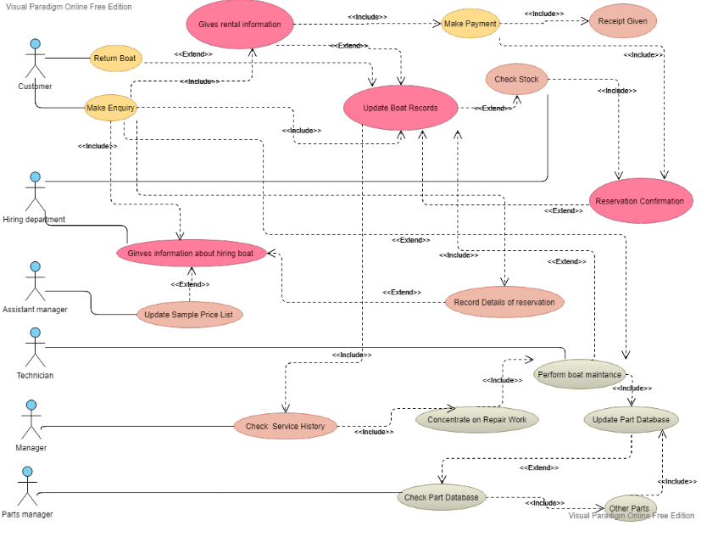

## 3b - Use Case Specifications

*Produce a use case specification for at least one UC per student. These should cover the most complex use cases found on the group UCD.*

Ibrahim’s (20027089) UCS:

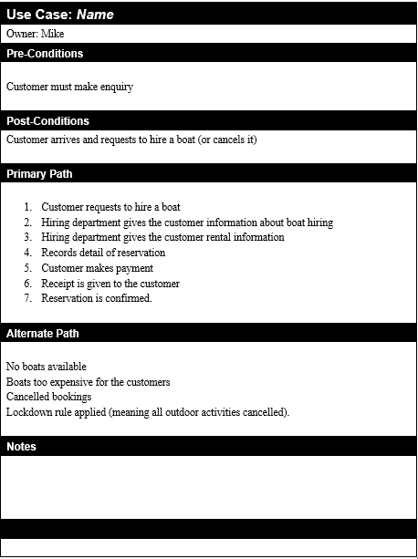

Abdulla’s (19027109) UCS:

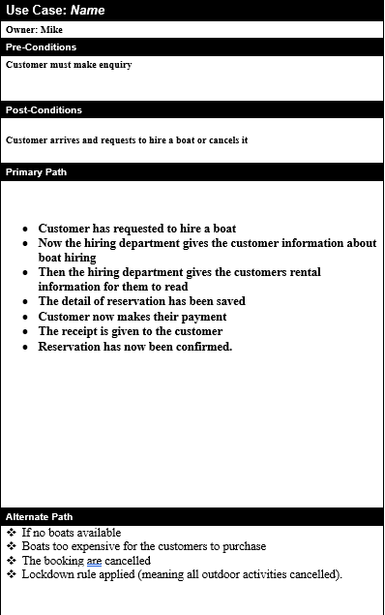

Anwar’s (20106726) UCS:

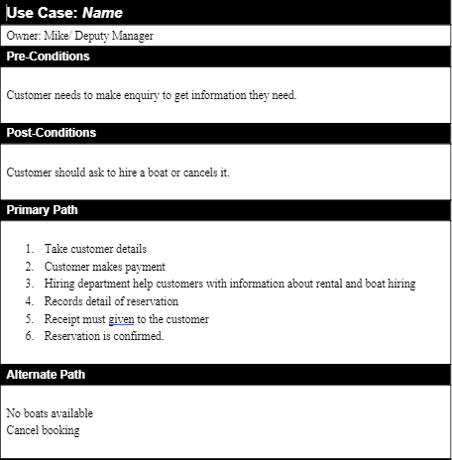

Bachar’s (18036978) UCS:

**\*incomplete\***

# Section 4: Database Design

## 4a - Top Down ERD

*Insert your finalised top down ERD here. Provide a written commentary explaining any decisions made in moving from the individual diagrams to the group one. The commentary should list any assumptions you have made.*

*Make sure diagram is readable and colours do not clash with the text*

*An individual entity relationship diagram (ERD) should be drawn by each member of the group. These need to be placed into the appendix of your report to provide evidence of participation, without these you will lose marks. Each one should have a student name/number associated with it. They must all be different.*

An ERD (entity relationship diagram) shows how entities relate to each other, simply means it’s a picture of a business process. Entities are things we store data to, in other words its glimpse of your business that stores data, such as stock order, manufacturer and more. We were given a task to create an individual ERD and a group ERD. Creating the individual ERD was different compared to the UCD it was slightly more complex and required a bit of thinking. When creating the group ERD it was a struggle since we had to combine the individual ERDs to create the group ERD then we had to decide whether to keep some parts or add on another class etc. We then got feedbacks and made some corrections to produce our final ERD (shown down below). So overall, our group ERD had much more information than the individual ERDs.

(Diagram shown below)

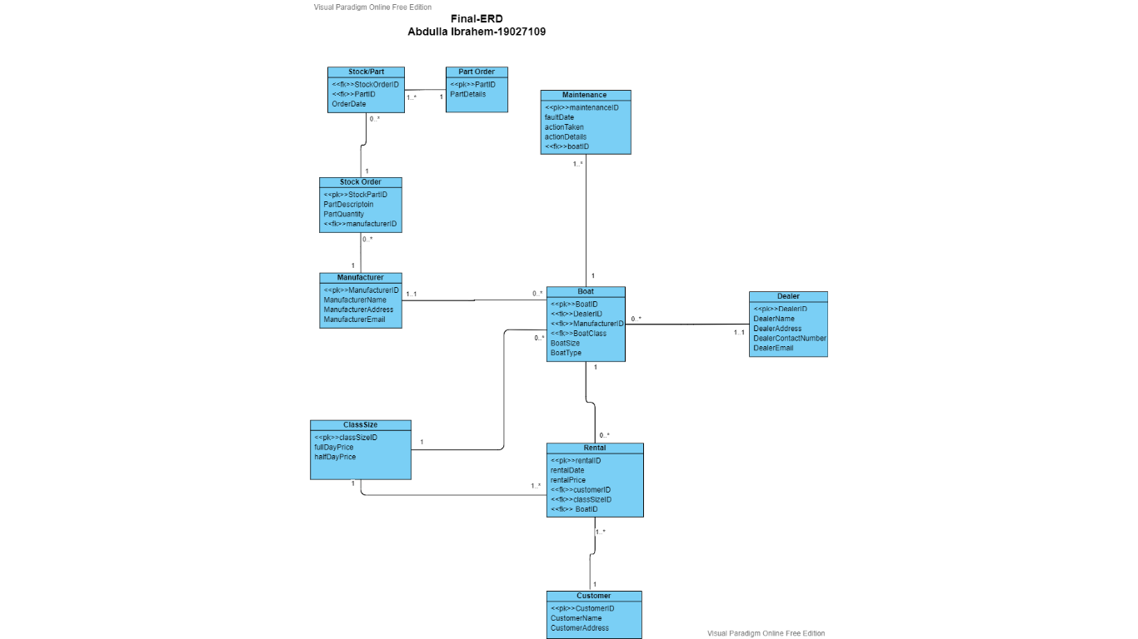

## 4b - Bottom Up ERD

**Boat Record Normalisation**

*Normalise the boat record showing all stages of the normalisation process (UNF, 1NF, 2NF, 3NF). Then produce a bottom up ERD from the tables produced at 3NF.*

*Make sure diagram is readable and colours do not clash with the text*

(Diagram shown below)

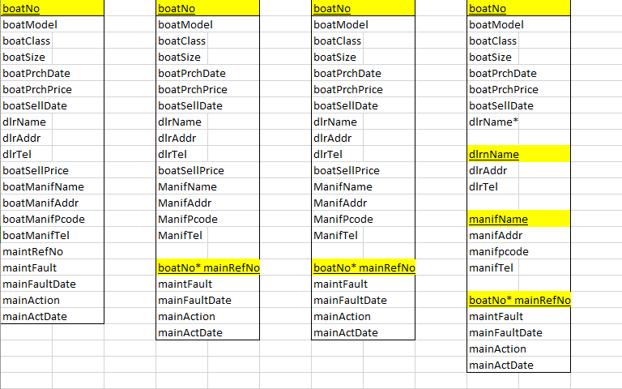

**Boat Record Normalisation**

**Rental Record Normalisation**

*Normalise the rental record showing all stages of the normalisation process (UNF, 1NF, 2NF, 3NF).*

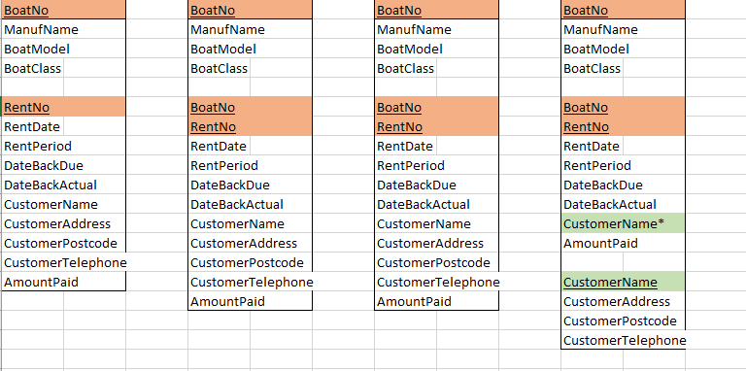

**Merged 3NFs from Normalisations and Bottom Up Data Model**

*Then produce a bottom up ERD from the tables produced at 3NF. Make sure diagram is readable and colours do not clash with the text*

Bottom up data model (Visual Paradigm)

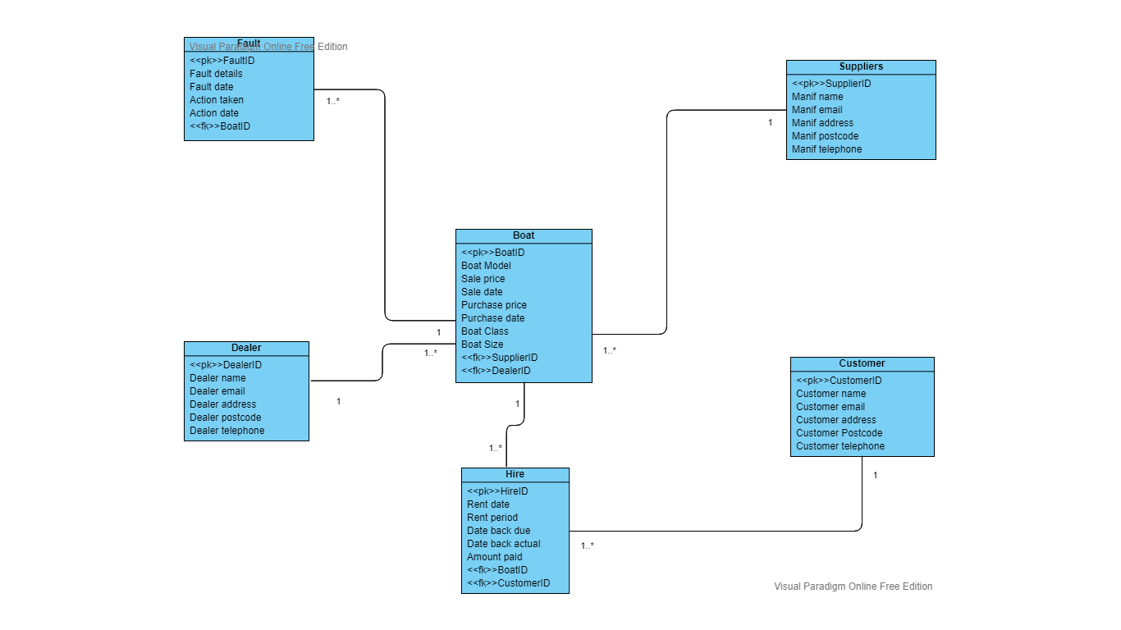

Bottom up data model (Excel)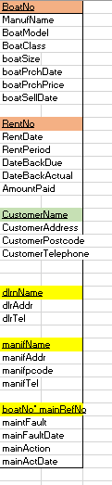 Merged 3NFs

## 4c - Merge of Top Down and Bottom Up ERD’s

*Merge your top down and bottom up data models to produce a final ERD. Make sure diagram is readable and colours do not clash with the text*

(Diagram shown below)

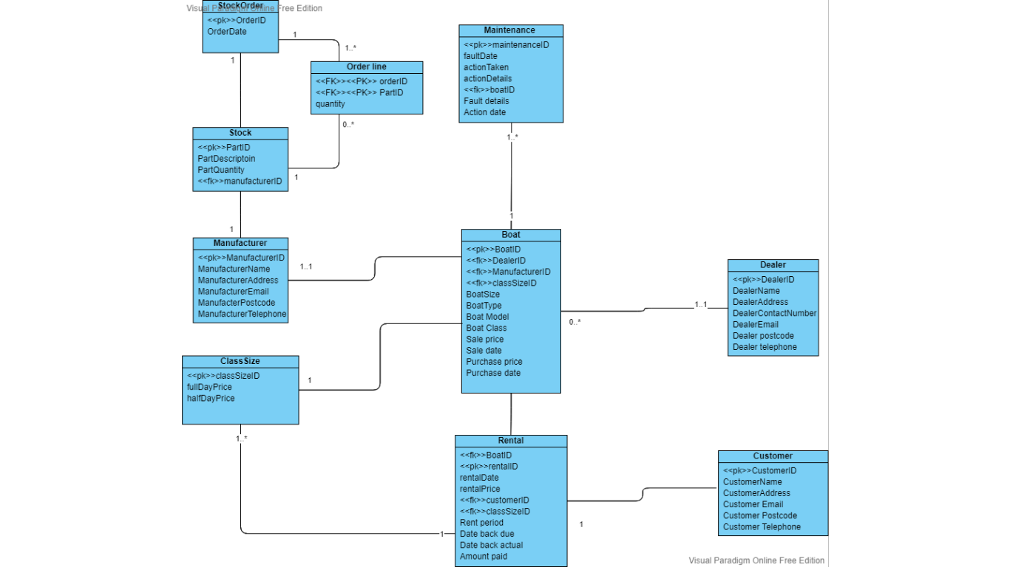

# Section 5: SQL Implementation

## 5a - Drop and Create Statements

*Include the code for all your DROP and CREATE statements.*

*DROP TABLE ORDER_LANE cascade constraints;*

*DROP TABLE STOCK cascade constraints;*

*DROP TABLE MAINTENANCE cascade constraints;*

*DROP TABLE RENTAL cascade constraints;*

*DROP TABLE BOAT cascade constraints;*

*DROP TABLE CLASS_SIZE cascade constraints;*

*DROP TABLE STOCK_ORDERS cascade constraints;*

*DROP TABLE DEALERS cascade constraints;*

*DROP TABLE MANUFACTURERS cascade constraints;*

*DROP TABLE CUSTOMERS cascade constraints;*

*CREATE TABLE CUSTOMERS(*

*CustomerID Number(8) PRIMARY KEY,*

*CustomerName Varchar(50),*

*CustomerTelNo Number(11),*

*CustomerAddress Varchar(50),*

*CustomerEmail Varchar2(50));*

*CREATE TABLE MANUFACTURERS(*

*ManufacturerID Number(8) PRIMARY KEY,*

*ManufName Varchar2(50),*

*ManufTelNo Number(11),*

*ManufAddress Varchar2(50),*

*ManufEmail Varchar2(50));*

*CREATE TABLE DEALERS(*

*DealerID Number(8) PRIMARY KEY,*

*DealName Varchar(50),*

*DealTelNo Number(11),*

*DealAddress Varchar(50),*

*DealEmail Varchar2(50));*

*CREATE TABLE STOCK_ORDERS(*

*OrderID Number(8) PRIMARY KEY,*

*OrderDate DATE);*

*CREATE TABLE CLASS_SIZE(*

*ClassSizeID Number(8) PRIMARY KEY ,*

*FullDayPrice Number(6),*

*HalfDayPrice Number(6));*

*CREATE TABLE BOAT(*

*BoatID NUMBER(8) PRIMARY KEY,*

*BoatModel VARCHAR2(50),*

*SalePrice Number(10),*

*DealerID Number(8),*

*ManufacturerID Number(8),*

*ClassSizeID Number(8),*

*SaleDate DATE,*

*PurchasePrice Number(10),*

*PurchaseDate DATE);*

*ALTER TABLE BOAT*

*ADD CONSTRAINT fk_Boat_dealerid FOREIGN KEY (DealerID) REFERENCES DEALERS(DealerID);*

*ALTER TABLE BOAT*

*ADD CONSTRAINT fk_Boat_classsizeid FOREIGN KEY (ClassSizeID) REFERENCES CLASS_SIZE(ClassSizeID);*

*ALTER TABLE BOAT*

*ADD CONSTRAINT fk_Boat_manufacturerid FOREIGN KEY (ManufacturerID) REFERENCES MANUFACTURERS(ManufacturerID);*

*CREATE TABLE RENTAL(*

*RentalID NUMBER(8) PRIMARY KEY,*

*BoatID Number(8),*

*RentalDate DATE,*

*RentalPrice Number(12),*

*CustomerID Number(8),*

*ClassSizeID Number(8),*

*RentalPeriod Number(4),*

*DateBackDue DATE,*

*DateBackActual DATE,*

*AmounPaid Number(6),*

*CONSTRAINT fk_Rental_boatid FOREIGN KEY (BoatID) REFERENCES BOAT(BoatID),*

*CONSTRAINT fk_Rental_customerid FOREIGN KEY (CustomerID) REFERENCES CUSTOMERS(CustomerID),*

*CONSTRAINT fk_Rental_classsizeid FOREIGN KEY (ClassSizeID) REFERENCES CLASS_SIZE(ClassSizeID)*

*);*

*CREATE TABLE MAINTENANCE(*

*MaintenanceID NUMBER(8) PRIMARY KEY,*

*BoatID Number(8),*

*FaultDate DATE,*

*FaultDetails VARCHAR2(50),*

*ActionTaken VARCHAR2(50),*

*ActionDetails VARCHAR2(50),*

*CONSTRAINT fk_maintenance_boatid FOREIGN KEY (BoatID) REFERENCES BOAT(BoatID)*

*);*

*CREATE TABLE STOCK(*

*PartID Number(8) PRIMARY KEY,*

*PartDescription VARCHAR2(50),*

*PartQuantity VARCHAR2(50),*

*MaintenanceID Number(8),*

*CONSTRAINT fk_stock_maintenanceid FOREIGN KEY (MaintenanceID) REFERENCES MAINTENANCE(MaintenanceID)*

*);*

*CREATE TABLE ORDER_LANE(*

*OrderID Number(8),*

*PartID Number (8),*

*Quantity Number(6),*

*CONSTRAINT pk_Order_Lane_orderandpart PRIMARY KEY (OrderID, PartID),*

*CONSTRAINT fk_Order_Lane_order FOREIGN KEY (OrderID) REFERENCES STOCK_ORDERS(OrderID),*

*CONSTRAINT fk_Order_Lane_Part FOREIGN KEY (PartID) REFERENCES STOCK(PartID)*

*);*

## 5b - Insert & Select Statements

*Include select statements showing all data has been correctly inserted.*

*INSERT INTO CUSTOMERS VALUES (1, 'Dion Brodnecke',7174826351,'Oak Street, Liverpool', 'dbroes1d@who.int ');*

*INSERT INTO CUSTOMERS VALUES (2, 'Scarlett Galley',03260476982,'886 Northport Parkway, Liverpool', 'scargr1c@imgur.com');*

*INSERT INTO CUSTOMERS VALUES (3, 'Sissy Gadson',4924556740,'95 Putney Road, Liverpool', 'sgadson1b@ucoz.com');*

*INSERT INTO CUSTOMERS VALUES (4, 'Tabby Minichi',7795213673,'6 Amoth Court, Warrington', 'minitabc@imgur.com');*

*INSERT INTO CUSTOMERS VALUES (5, 'Nellie Greenmon',3816078215,'40 Graceland Crossing, Liverpool', 'nelliegreen12@patch.com');*

*INSERT INTO CUSTOMERS VALUES (6, 'Hanny Marsters ',07075576685 ,'2 Almo Trail, Liverpool', 'hmarsters@netlog.com');*

*INSERT INTO CUSTOMERS VALUES (7, 'Oswell Aspinell',09931348133 ,'64 Jackson Road, Liverpool', 'OsAspinell@digg.com');*

*INSERT INTO CUSTOMERS VALUES (8, 'Florance Baston ',07315082134 ,'440 Magdeline Lane, Warrington', 'FloBar@dirtg.com');*

*INSERT INTO CUSTOMERS VALUES (9, 'Candice Tumilson',016398246574,'1 Farragut Parkway, Liverpool', 'nelliegreen12@patch.com');*

*INSERT INTO CUSTOMERS VALUES (10, 'Clair Bavin',06245985897,'87 Toban Drive, Liverpool', ' clairBav@sprog.it');*

*INSERT INTO MANUFACTURERS VALUES (1, 'SuperBoat',01772459666,'Unit 7 Centurian Court, Leyland', 'admin@superboat.co.uk');*

*INSERT INTO MANUFACTURERS VALUES (2, 'Explorer Boats UK',01704807654,'Meadow Lane, Burscough', 'admin@explorerboats.co.uk');*

*INSERT INTO MANUFACTURERS VALUES (3, 'The Northwich Boat, Company',01270160160,'Uint 1 Kings Lock Boattard Booth Lane,Middlewich', 'admin@northwichboats.co.uk');*

*INSERT INTO MANUFACTURERS VALUES (4, 'Collingwood Boat Builder',01513742985,'9 Townsend Street', 'admin@collingwoodboats.co.uk');*

*INSERT INTO MANUFACTURERS VALUES (5, 'Elto Moss Boat Builders',01270760160,'Unit 4 Kings Lock Boatyard BoothLane, Middlewich', 'admin@eltonmossboats.co.uk');*

*INSERT INTO MANUFACTURERS VALUES (6, 'Aintree Boat Company Ltd',01515239000,'Brookfield Drive, Liverpool ', 'admin@eltonmossboats.co.uk');*

*INSERT INTO MANUFACTURERS VALUES (7, 'Braidbar Boats Ltd',01625873471,'Lord Vernons Wharf Lyme Road Higher, Poynton', 'admin@eltonmossboats.co.uk');*

*INSERT INTO MANUFACTURERS VALUES (8, 'Bourne Boat Builders Ltd ',01785714692 ,'Teddesley Road, Penkridge', 'admin@eltonmossboats.co.uk');*

*INSERT INTO MANUFACTURERS VALUES (9, 'Stoke on Trent Boat Building Co Ltd ',01782813831 ,'Longport Wharf Station Street, Stoke-on-Trent ', 'admin@eltonmossboats.co.uk');*

*INSERT INTO DEALERS VALUES (1, 'Dalis Vannoort',07574137463,'77 A828, Appin', 'dvannoort0@salon.com');*

*INSERT INTO DEALERS VALUES (2, 'Joes Junk',07365534221,'15 Back Lane, Buxton', 'JoesJunk@zdnet.com ');*

*INSERT INTO DEALERS VALUES (3, 'Hoebart Kubera',07874051869,'4 Finedon House, Marine Parade, Littlestone', 'hkubera2@who.int ');*

*INSERT INTO DEALERS VALUES (4, 'Eva Iacomettii',07880072148,'9 Hartlands, Onslow Road, Newwent', 'eiacomettii3@admin.ch');*

*INSERT INTO DEALERS VALUES (5, 'Alley Pate',07822040557,'07610 Arizona Alley', 'apate4@gnu.org');*

*INSERT INTO DEALERS VALUES (6, 'Korrie Legge',07380018233,'1076 Evesham Road, Astwood Bank ', 'klegge5@reference.com');*

*INSERT INTO DEALERS VALUES (7, 'Minne Hinkens',07978390430,'53 Balby Road, Balby', 'mhinken6@smh.com.au');*

*INSERT INTO DEALERS VALUES (8, 'Inigo MacAllaster',07893419552,'1910 Farwell Plaza', 'imacallaster7@blogspot.com');*

*INSERT INTO DEALERS VALUES (9, 'Linell Skeeles',07532931207,'57 Great Russell Street, London', 'Iskeeles8@goo.gl');*

*INSERT INTO CLASS_SIZE VALUES (1, '240','170');*

*INSERT INTO CLASS_SIZE VALUES (2, '180','120');*

*INSERT INTO CLASS_SIZE VALUES (3, '160','100');*

*INSERT INTO CLASS_SIZE VALUES (4, '140','90');*

*INSERT INTO CLASS_SIZE VALUES (5, '280','175');*

*INSERT INTO CLASS_SIZE VALUES (6, '240','150');*

*INSERT INTO CLASS_SIZE VALUES (7, '200','125');*

*INSERT INTO CLASS_SIZE VALUES (8, '170','125');*

*INSERT INTO CLASS_SIZE VALUES (9, '160','100');*

*INSERT INTO CLASS_SIZE VALUES (10, '150','140');*

*INSERT INTO BOAT VALUES (1, 'Explorer', 3910,1,1,1, '10-Oct-2019 ',280,'20-Oct-2020 ' );*

*INSERT INTO BOAT VALUES (2, 'TurboSail ',3840,2,2,2, '10-Oct-2019 ', 220,'20-Oct-2020 ');*

*INSERT INTO BOAT VALUES (3, 'MasterSail',3240,3,3,3, '10-Oct-2019 ', 240, '20-Oct-2020 ');*

*INSERT INTO BOAT VALUES (4, 'SmallSailor', 2040,4,4,4, '10-Oct-2019 ', 240, '20-Oct-2020 ');*

*INSERT INTO BOAT VALUES (5, 'SmallSailor',2040,5,5,5, '10-Oct-2019 ',140, '20-Oct-2020 ');*

*INSERT INTO BOAT VALUES (6, 'Grande',5440,6,6,6, '10-Oct-2019 ', 240, '20-Oct-2020 ');*

*INSERT INTO BOAT VALUES (7, 'Grande ',5440,7,7,7, '10-Oct-2019 ', 180, '20-Oct-2020 ');*

*INSERT INTO BOAT VALUES (8, 'Turbo Mid',5440,8,8,8, '10-Oct-2019 ', 110, '20-Oct-2020 ');*

*INSERT INTO BOAT VALUES (9, 'RowStream',440 ,9,9,9, '10-Oct-2019 ',110, '20-Oct-2020 ');*

*INSERT INTO BOAT VALUES (10, 'RowerX',320 ,9,9,9, '10-Oct-2019 ',110, '20-Oct-2020 ');*

*INSERT INTO RENTAL VALUES (1, 1,' 20-Oct-2020', 140,1,1,2,'02-may-2017','03-may-2017',180.00);*

*INSERT INTO RENTAL VALUES (2, 2,' 20-Oct-2020', 240,2,2,3,'03-may-2017','06-may-2017',170.00);*

*INSERT INTO RENTAL VALUES (3, 3,' 20-Oct-2020', 180,3,3,2,'04-may-2017','06-may-2017',240.00);*

*INSERT INTO RENTAL VALUES (4, 4,' 20-Oct-2020', 110,4,4,3,'05-may-2017','06-may-2017',240.00);*

*INSERT INTO RENTAL VALUES (5, 5,' 20-Oct-2020', 110,5,5,1,'06-may-2017','02-may-2017',240.00);*

*INSERT INTO RENTAL VALUES (6, 6,' 20-Oct-2020', 400,6,6,6,'07-may-2017','05-may-2017',170.00);*

*INSERT INTO RENTAL VALUES (7, 7,' 20-Oct-2020', 180,7,7,3,'08-may-2017','06-may-2017',170.00);*

*INSERT INTO RENTAL VALUES (8, 8,' 20-Oct-2020', 110,8,8,1,'09-may-2017','06-may-2017',180.00);*

*INSERT INTO RENTAL VALUES (9, 9,' 20-Oct-2020', 400,9,9,2,'06-may-2017','06-may-2017',180.00);*

*INSERT INTO RENTAL VALUES (10,10,' 20-Oct-2020',200,10,10,4,'06-may-2017','06-may-2017',180.00);*

*INSERT INTO MAINTENANCE VALUES (1, 1, '17-apr-2016','Damaged mast',' Repair Mast','27-apr-2016');*

*INSERT INTO MAINTENANCE VALUES (2, 2, '10-jul-2017','Bent Forestay','Replace Forestay','22-aug-2017');*

*INSERT INTO MAINTENANCE VALUES (3, 3, '07-may-2018','Shot Boom','Replace Boom','06-june-2018');*

*INSERT INTO MAINTENANCE VALUES (4, 4, '07-jul-2019','Shot Boom','Repair Rudderstock','08-jul-2019');*

*INSERT INTO MAINTENANCE VALUES (5, 5, '19-oct-2020','Rudderstock Chipped','Normal Service','27-jan-2020');*

*INSERT INTO MAINTENANCE VALUES (6, 6, '19-oct-2020',' Rudderblade busted ','Normal Service','27-jan-2020');*

*INSERT INTO MAINTENANCE VALUES (7, 7, '19-oct-2020',' Rudderblade busted ','Normal Service','06-june-2018');*

*INSERT INTO STOCK VALUES (1,'Sail boat ', 'two',1);*

*INSERT INTO STOCK VALUES (2,'Sail boat ', 'three',2);*

*INSERT INTO STOCK VALUES (3,'Rowing boat ', 'fuor',3);*

*INSERT INTO STOCK VALUES (4,'Motorboat', 'six',4);*

*INSERT INTO STOCK_ORDERS VALUES (1, '02-FEB-2016');*

*INSERT INTO STOCK_ORDERS VALUES (2, '12 Oct 15');*

# Section 6: SQL Queries

*Include a screenshot of the query created and the output result clearly indicating who has written the query.*

## Query 2

## Query 7

# Section 7: Student Statements

*Each team member should provide a commentary describing what they have learnt during the whole project.*

## Student A – Ibrahim Chowdhury (20027089)

This project has been very interesting and unique, it contained many different styles of diagrams and databases. On the learning side of this project, it went very well as it was easily explained and taught by the teacher, this project was very practical and required a lot of trial and error. This was also a group project which included 4 other students, we had to work together on some parts of the project to complete it. We did have some issues with that whether it was the learning aspects or the lack of contribution from the students. However, at the end we did manage to complete it.

## Student B – Abdulla Ibrahem (19027109)

I have enjoyed doing this group project because it has several types of diagrams and databases. I have learned a lot of new skills from this project, which was the online visual paradigm, it has an excellent tool to draw UCD, ERD and much more enjoyable tools. Oracle Academy also was a new platform for me that I had learned so many things such as creating, dropping, and inserting statements. As a group, we helped each other’s and worked hard. We also have faced many difficulties and challenges during the group project; however, I have improved my communication skills and gained more confidence.

## Student C – Anwar Aldhufairy and 20106726

**\*incomplete\***

## Student D – Bachar Alhussain (18036978)

**\*incomplete\***

# Appendix A: Individual UCD Attempts

Ibrahim’s UCD (20027089):

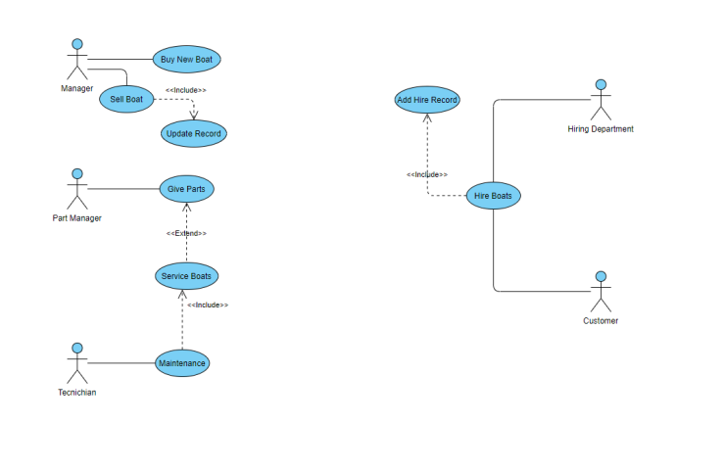

Abdulla’s UCD (19027109):

Anwar’s UCD (20106726):

Bachar’s UCD (18036978):

# Appendix B: Individual ERD Attempts

Ibrahim’s ERD (20027089):

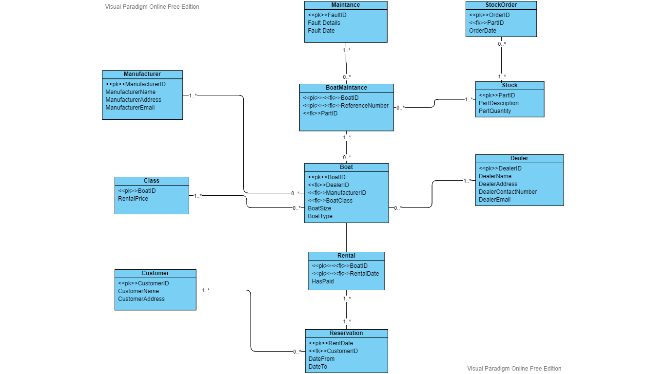

Abdulla’s ERD (19027109):

Anwar’s ERD (20106726):

Bachar’s ERD (18036978):

# Appendix C: Logbook

*Copy and paste all of your logbook entries here*

*Each logbook should clearly display the following:*

**Date: 12/04/2021**

**Names of those present:** Ibrahim, Abdulla, Anwar and Bachar

**Names of those absent:** No one was absent.

**What was discussed:**

We were discussing about the UCD and what day we should get it done, we also chipped in ideas on how to complete the UCD and went through some of the lecture videos/ webinars.

**Action plan:**

**Everyone:** Completed individual UCD

**Date: 13/04/2021**

**Names of those present:** Ibrahim, Abdulla, Anwar and Bachar

**Names of those absent:** No one was absent.

**What was discussed:**

We were discussing on how to complete the UCD and comparing our individual UCD and picking out ideas to implement onto the group UCD.

**Action plan:**

**Everyone:** Create group UCD.

**Date: 17/04/2021**

**Names of those present:** Ibrahim, Abdulla, Anwar and Bachar

**Names of those absent:** No one was absent

**What was discussed:**

Here we were finalising our group UCD and just finishing of some last bits and pieces and then completed it. Then we agreed on making our individual ERD.

**Action plan:**

**Everyone:** Create an individual ERD.

**Date: 21/04/2021**

**Names of those present:** Ibrahim and Abdulla

**Names of those absent:** Anwar and Bachar

**What was discussed:**

Here, we were supposed to have our individual ERD all completed but Anwar and Bachar was absent during this time with no response, I alerted them but received no answer. So, me (Ibrahim) and Abdulla went ahead with the group ERD.

**Action plan:**

**Abdulla:** Compare individual ERD and then complete a group ERD together

**Ibrahim:** Compare individual ERD and then complete a group ERD together

**Date: 24/04/2021**

**Names of those present:** Ibrahim and Abdulla

**Names of those absent:** Anwar and Bachar

**What was discussed:**

Now we have completed the group ERD and Abdulla sent it to the teacher for feedback, when Abdulla got his feedback, he fixed the corrections on the ERD. Me (Ibrahim) and Abdulla then decided that I (Ibrahim) should create the normalisation and bottom up ERD and Abdulla will be helping. Anwar and Bachar were absent during this time.

**Action plan:**

**Ibrahim:** Complete the normalisation stages including the merge stages of the 3NFs and create a bottom up ERD

**Abdulla:** Help Ibrahim, with creating the normalisation stages and bottom up ERD.

**Date: 26/04/2021**

**Names of those present:** Ibrahim and Abdulla

**Names of those absent:** Anwar and Bachar

**What was discussed:**

Here, me (Ibrahim) and Abdulla completed the normalisation and bottom up ERD, and I (Ibrahim) mentioned to the whole group to complete the individual ERD. After that, me (Ibrahim) and Abdulla discussed on how to merge to merge the bottom up ERD to the top bottom ERD. Anwar and Bachar were absent during this time.

**Action plan:**

**Ibrahim:** Merge the bottom up ERD to the top bottom ERD, to create a final ERD.

**Abdulla:** Help Ibrahim on combining the bottom up ERD to the top bottom ERD.

**Date: 3/05/2021**

**Names of those present:** Ibrahim and Abdulla

**Names of those absent:** Anwar and Bachar

**What was discussed:**

We both managed to combine the 2 ERDs bottom up and top bottom to create this big final ERD, we then sent it to Stephen to get feedback, after correcting the mistakes we were then ready to implement.

**Action plan:**

**Abdulla:** Create database with all the tables and save the statements in a script and upload to oracle.

**Ibrahim:** Help Abdulla on creating database and statements.

**Date: 4/05/2021**

**Names of those present:** Ibrahim and Abdulla

**Names of those absent:** Anwar and Bachar

**What was discussed:**

We both helped each other out and completed the database and uploaded the script to oracle, we then discussed how to complete the Data Base script and insert data

**Action plan:**

**Abdulla:** Complete the DB and insert the data.

**Ibrahim:** Help Abdulla to complete the DB and inserting the data.

**Date: 5/05/2021**

**Names of those present:** Ibrahim and Abdulla

**Names of those absent:** Anwar and Bachar

**What was discussed:**

We completed the DB and inserting data, which then led us to talk about producing the queries for MM database.

**Action plan:**

**Abdulla:** Produce queries for MM database.

**Ibrahim:** Help Abdulla on producing queries for MM database.

**Date: 6/05/2021**

**Names of those present:** Ibrahim and Abdulla

**Names of those absent:** Anwar and Bachar

**What was discussed:**

Me (Ibrahim) and Abdulla completed the queries filled out the report and double checked if there was anything to add or remove, we discussed if anything had to be improved and was is it to the high level of standards. We then got everything organised in the correct files and decided to submit the assignment, (Anwar and Bachar were absent during these times).

**Action plan:**

**Abdulla:** Submit the assignment

**Ibrahim:** Submit the assignment.

# Appendix D: Full SQL Code

*Copy and paste all of your SQL code here DROP TABLE ORDER_LANE cascade constraints;*

*DROP TABLE STOCK cascade constraints;*

*DROP TABLE MAINTENANCE cascade constraints;*

*DROP TABLE RENTAL cascade constraints;*

*DROP TABLE BOAT cascade constraints;*

*DROP TABLE CLASS_SIZE cascade constraints;*

*DROP TABLE STOCK_ORDERS cascade constraints;*

*DROP TABLE DEALERS cascade constraints;*

*DROP TABLE MANUFACTURERS cascade constraints;*

*DROP TABLE CUSTOMERS cascade constraints;*

*CREATE TABLE CUSTOMERS(*

*CustomerID Number(8) PRIMARY KEY,*

*CustomerName Varchar(50),*

*CustomerTelNo Number(11),*

*CustomerAddress Varchar(50),*

*CustomerEmail Varchar2(50));*

*CREATE TABLE MANUFACTURERS(*

*ManufacturerID Number(8) PRIMARY KEY,*

*ManufName Varchar2(50),*

*ManufTelNo Number(11),*

*ManufAddress Varchar2(50),*

*ManufEmail Varchar2(50));*

*CREATE TABLE DEALERS(*

*DealerID Number(8) PRIMARY KEY,*

*DealName Varchar(50),*

*DealTelNo Number(11),*

*DealAddress Varchar(50),*

*DealEmail Varchar2(50));*

*CREATE TABLE STOCK_ORDERS(*

*OrderID Number(8) PRIMARY KEY,*

*OrderDate DATE);*

*CREATE TABLE CLASS_SIZE(*

*ClassSizeID Number(8) PRIMARY KEY ,*

*FullDayPrice Number(6),*

*HalfDayPrice Number(6));*

*CREATE TABLE BOAT(*

*BoatID NUMBER(8) PRIMARY KEY,*

*BoatModel VARCHAR2(50),*

*SalePrice Number(10),*

*DealerID Number(8),*

*ManufacturerID Number(8),*

*ClassSizeID Number(8),*

*SaleDate DATE,*

*PurchasePrice Number(10),*

*PurchaseDate DATE);*

*ALTER TABLE BOAT*

*ADD CONSTRAINT fk_Boat_dealerid FOREIGN KEY (DealerID) REFERENCES DEALERS(DealerID);*

*ALTER TABLE BOAT*

*ADD CONSTRAINT fk_Boat_classsizeid FOREIGN KEY (ClassSizeID) REFERENCES CLASS_SIZE(ClassSizeID);*

*ALTER TABLE BOAT*

*ADD CONSTRAINT fk_Boat_manufacturerid FOREIGN KEY (ManufacturerID) REFERENCES MANUFACTURERS(ManufacturerID);*

*CREATE TABLE RENTAL(*

*RentalID NUMBER(8) PRIMARY KEY,*

*BoatID Number(8),*

*RentalDate DATE,*

*RentalPrice Number(12),*

*CustomerID Number(8),*

*ClassSizeID Number(8),*

*RentalPeriod Number(4),*

*DateBackDue DATE,*

*DateBackActual DATE,*

*AmounPaid Number(6),*

*CONSTRAINT fk_Rental_boatid FOREIGN KEY (BoatID) REFERENCES BOAT(BoatID),*

*CONSTRAINT fk_Rental_customerid FOREIGN KEY (CustomerID) REFERENCES CUSTOMERS(CustomerID),*

*CONSTRAINT fk_Rental_classsizeid FOREIGN KEY (ClassSizeID) REFERENCES CLASS_SIZE(ClassSizeID)*

*);*

*CREATE TABLE MAINTENANCE(*

*MaintenanceID NUMBER(8) PRIMARY KEY,*

*BoatID Number(8),*

*FaultDate DATE,*

*FaultDetails VARCHAR2(50),*

*ActionTaken VARCHAR2(50),*

*ActionDetails VARCHAR2(50),*

*CONSTRAINT fk_maintenance_boatid FOREIGN KEY (BoatID) REFERENCES BOAT(BoatID)*

*);*

*CREATE TABLE STOCK(*

*PartID Number(8) PRIMARY KEY,*

*PartDescription VARCHAR2(50),*

*PartQuantity VARCHAR2(50),*

*MaintenanceID Number(8),*

*CONSTRAINT fk_stock_maintenanceid FOREIGN KEY (MaintenanceID) REFERENCES MAINTENANCE(MaintenanceID)*

*);*

*CREATE TABLE ORDER_LANE(*

*OrderID Number(8),*

*PartID Number (8),*

*Quantity Number(6),*

*CONSTRAINT pk_Order_Lane_orderandpart PRIMARY KEY (OrderID, PartID),*

*CONSTRAINT fk_Order_Lane_order FOREIGN KEY (OrderID) REFERENCES STOCK_ORDERS(OrderID),*

*CONSTRAINT fk_Order_Lane_Part FOREIGN KEY (PartID) REFERENCES STOCK(PartID)*

*);*

*INSERT INTO CUSTOMERS VALUES (1, 'Dion Brodnecke',7174826351,'Oak Street, Liverpool', 'dbroes1d@who.int ');*

*INSERT INTO CUSTOMERS VALUES (2, 'Scarlett Galley',03260476982,'886 Northport Parkway, Liverpool', 'scargr1c@imgur.com');*

*INSERT INTO CUSTOMERS VALUES (3, 'Sissy Gadson',4924556740,'95 Putney Road, Liverpool', 'sgadson1b@ucoz.com');*

*INSERT INTO CUSTOMERS VALUES (4, 'Tabby Minichi',7795213673,'6 Amoth Court, Warrington', 'minitabc@imgur.com');*

*INSERT INTO CUSTOMERS VALUES (5, 'Nellie Greenmon',3816078215,'40 Graceland Crossing, Liverpool', 'nelliegreen12@patch.com');*

*INSERT INTO CUSTOMERS VALUES (6, 'Hanny Marsters ',07075576685 ,'2 Almo Trail, Liverpool', 'hmarsters@netlog.com');*

*INSERT INTO CUSTOMERS VALUES (7, 'Oswell Aspinell',09931348133 ,'64 Jackson Road, Liverpool', 'OsAspinell@digg.com');*

*INSERT INTO CUSTOMERS VALUES (8, 'Florance Baston ',07315082134 ,'440 Magdeline Lane, Warrington', 'FloBar@dirtg.com');*

*INSERT INTO CUSTOMERS VALUES (9, 'Candice Tumilson',016398246574,'1 Farragut Parkway, Liverpool', 'nelliegreen12@patch.com');*

*INSERT INTO CUSTOMERS VALUES (10, 'Clair Bavin',06245985897,'87 Toban Drive, Liverpool', ' clairBav@sprog.it');*

*INSERT INTO MANUFACTURERS VALUES (1, 'SuperBoat',01772459666,'Unit 7 Centurian Court, Leyland', 'admin@superboat.co.uk');*

*INSERT INTO MANUFACTURERS VALUES (2, 'Explorer Boats UK',01704807654,'Meadow Lane, Burscough', 'admin@explorerboats.co.uk');*

*INSERT INTO MANUFACTURERS VALUES (3, 'The Northwich Boat, Company',01270160160,'Uint 1 Kings Lock Boattard Booth Lane,Middlewich', 'admin@northwichboats.co.uk');*

*INSERT INTO MANUFACTURERS VALUES (4, 'Collingwood Boat Builder',01513742985,'9 Townsend Street', 'admin@collingwoodboats.co.uk');*

*INSERT INTO MANUFACTURERS VALUES (5, 'Elto Moss Boat Builders',01270760160,'Unit 4 Kings Lock Boatyard BoothLane, Middlewich', 'admin@eltonmossboats.co.uk');*

*INSERT INTO MANUFACTURERS VALUES (6, 'Aintree Boat Company Ltd',01515239000,'Brookfield Drive, Liverpool ', 'admin@eltonmossboats.co.uk');*

*INSERT INTO MANUFACTURERS VALUES (7, 'Braidbar Boats Ltd',01625873471,'Lord Vernons Wharf Lyme Road Higher, Poynton', 'admin@eltonmossboats.co.uk');*

*INSERT INTO MANUFACTURERS VALUES (8, 'Bourne Boat Builders Ltd ',01785714692 ,'Teddesley Road, Penkridge', 'admin@eltonmossboats.co.uk');*

*INSERT INTO MANUFACTURERS VALUES (9, 'Stoke on Trent Boat Building Co Ltd ',01782813831 ,'Longport Wharf Station Street, Stoke-on-Trent ', 'admin@eltonmossboats.co.uk');*

*INSERT INTO DEALERS VALUES (1, 'Dalis Vannoort',07574137463,'77 A828, Appin', 'dvannoort0@salon.com');*

*INSERT INTO DEALERS VALUES (2, 'Joes Junk',07365534221,'15 Back Lane, Buxton', 'JoesJunk@zdnet.com ');*

*INSERT INTO DEALERS VALUES (3, 'Hoebart Kubera',07874051869,'4 Finedon House, Marine Parade, Littlestone', 'hkubera2@who.int ');*

*INSERT INTO DEALERS VALUES (4, 'Eva Iacomettii',07880072148,'9 Hartlands, Onslow Road, Newwent', 'eiacomettii3@admin.ch');*

*INSERT INTO DEALERS VALUES (5, 'Alley Pate',07822040557,'07610 Arizona Alley', 'apate4@gnu.org');*

*INSERT INTO DEALERS VALUES (6, 'Korrie Legge',07380018233,'1076 Evesham Road, Astwood Bank ', 'klegge5@reference.com');*

*INSERT INTO DEALERS VALUES (7, 'Minne Hinkens',07978390430,'53 Balby Road, Balby', 'mhinken6@smh.com.au');*

*INSERT INTO DEALERS VALUES (8, 'Inigo MacAllaster',07893419552,'1910 Farwell Plaza', 'imacallaster7@blogspot.com');*

*INSERT INTO DEALERS VALUES (9, 'Linell Skeeles',07532931207,'57 Great Russell Street, London', 'Iskeeles8@goo.gl');*

*INSERT INTO CLASS_SIZE VALUES (1, '240','170');*

*INSERT INTO CLASS_SIZE VALUES (2, '180','120');*

*INSERT INTO CLASS_SIZE VALUES (3, '160','100');*

*INSERT INTO CLASS_SIZE VALUES (4, '140','90');*

*INSERT INTO CLASS_SIZE VALUES (5, '280','175');*

*INSERT INTO CLASS_SIZE VALUES (6, '240','150');*

*INSERT INTO CLASS_SIZE VALUES (7, '200','125');*

*INSERT INTO CLASS_SIZE VALUES (8, '170','125');*

*INSERT INTO CLASS_SIZE VALUES (9, '160','100');*

*INSERT INTO CLASS_SIZE VALUES (10, '150','140');*

*INSERT INTO BOAT VALUES (1, 'Explorer', 3910,1,1,1, '10-Oct-2019 ',280,'20-Oct-2020 ' );*

*INSERT INTO BOAT VALUES (2, 'TurboSail ',3840,2,2,2, '10-Oct-2019 ', 220,'20-Oct-2020 ');*

*INSERT INTO BOAT VALUES (3, 'MasterSail',3240,3,3,3, '10-Oct-2019 ', 240, '20-Oct-2020 ');*

*INSERT INTO BOAT VALUES (4, 'SmallSailor', 2040,4,4,4, '10-Oct-2019 ', 240, '20-Oct-2020 ');*

*INSERT INTO BOAT VALUES (5, 'SmallSailor',2040,5,5,5, '10-Oct-2019 ',140, '20-Oct-2020 ');*

*INSERT INTO BOAT VALUES (6, 'Grande',5440,6,6,6, '10-Oct-2019 ', 240, '20-Oct-2020 ');*

*INSERT INTO BOAT VALUES (7, 'Grande ',5440,7,7,7, '10-Oct-2019 ', 180, '20-Oct-2020 ');*

*INSERT INTO BOAT VALUES (8, 'Turbo Mid',5440,8,8,8, '10-Oct-2019 ', 110, '20-Oct-2020 ');*

*INSERT INTO BOAT VALUES (9, 'RowStream',440 ,9,9,9, '10-Oct-2019 ',110, '20-Oct-2020 ');*

*INSERT INTO BOAT VALUES (10, 'RowerX',320 ,9,9,9, '10-Oct-2019 ',110, '20-Oct-2020 ');*

*INSERT INTO RENTAL VALUES (1, 1,' 20-Oct-2020', 140,1,1,2,'02-may-2017','03-may-2017',180.00);*

*INSERT INTO RENTAL VALUES (2, 2,' 20-Oct-2020', 240,2,2,3,'03-may-2017','06-may-2017',170.00);*

*INSERT INTO RENTAL VALUES (3, 3,' 20-Oct-2020', 180,3,3,2,'04-may-2017','06-may-2017',240.00);*

*INSERT INTO RENTAL VALUES (4, 4,' 20-Oct-2020', 110,4,4,3,'05-may-2017','06-may-2017',240.00);*

*INSERT INTO RENTAL VALUES (5, 5,' 20-Oct-2020', 110,5,5,1,'06-may-2017','02-may-2017',240.00);*

*INSERT INTO RENTAL VALUES (6, 6,' 20-Oct-2020', 400,6,6,6,'07-may-2017','05-may-2017',170.00);*

*INSERT INTO RENTAL VALUES (7, 7,' 20-Oct-2020', 180,7,7,3,'08-may-2017','06-may-2017',170.00);*

*INSERT INTO RENTAL VALUES (8, 8,' 20-Oct-2020', 110,8,8,1,'09-may-2017','06-may-2017',180.00);*

*INSERT INTO RENTAL VALUES (9, 9,' 20-Oct-2020', 400,9,9,2,'06-may-2017','06-may-2017',180.00);*

*INSERT INTO RENTAL VALUES (10,10,' 20-Oct-2020',200,10,10,4,'06-may-2017','06-may-2017',180.00);*

*INSERT INTO MAINTENANCE VALUES (1, 1, '17-apr-2016','Damaged mast',' Repair Mast','27-apr-2016');*

*INSERT INTO MAINTENANCE VALUES (2, 2, '10-jul-2017','Bent Forestay','Replace Forestay','22-aug-2017');*

*INSERT INTO MAINTENANCE VALUES (3, 3, '07-may-2018','Shot Boom','Replace Boom','06-june-2018');*

*INSERT INTO MAINTENANCE VALUES (4, 4, '07-jul-2019','Shot Boom','Repair Rudderstock','08-jul-2019');*

*INSERT INTO MAINTENANCE VALUES (5, 5, '19-oct-2020','Rudderstock Chipped','Normal Service','27-jan-2020');*

*INSERT INTO MAINTENANCE VALUES (6, 6, '19-oct-2020',' Rudderblade busted ','Normal Service','27-jan-2020');*

*INSERT INTO MAINTENANCE VALUES (7, 7, '19-oct-2020',' Rudderblade busted ','Normal Service','06-june-2018');*

*INSERT INTO STOCK VALUES (1,'Sail boat ', 'two',1);*

*INSERT INTO STOCK VALUES (2,'Sail boat ', 'three',2);*

*INSERT INTO STOCK VALUES (3,'Rowing boat ', 'fuor',3);*

*INSERT INTO STOCK VALUES (4,'Motorboat', 'six',4);*

*INSERT INTO STOCK_ORDERS VALUES (1, '02-FEB-2016');*

*INSERT INTO STOCK_ORDERS VALUES (2, '12 Oct 15');*